This document details how to install git on laptop and set up a project with Partners gitlab.

- Download git on your laptop
https://git-scm.com
- Open your terminal (for Mac) or command prompt (for Windows), type “git”. You should see something like this
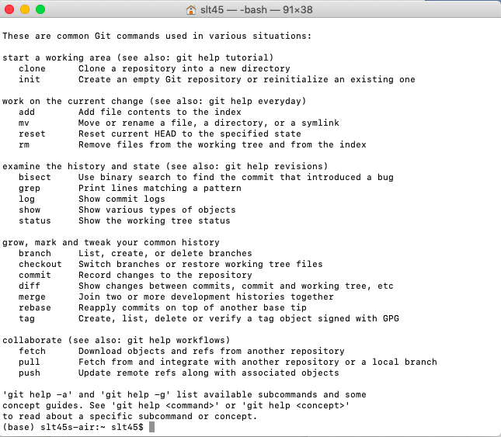
- Go to https://gitlab.partners.org/users/sign_in
- Sign in with your Partners username and password
- Create a private group- only share with people who should get access
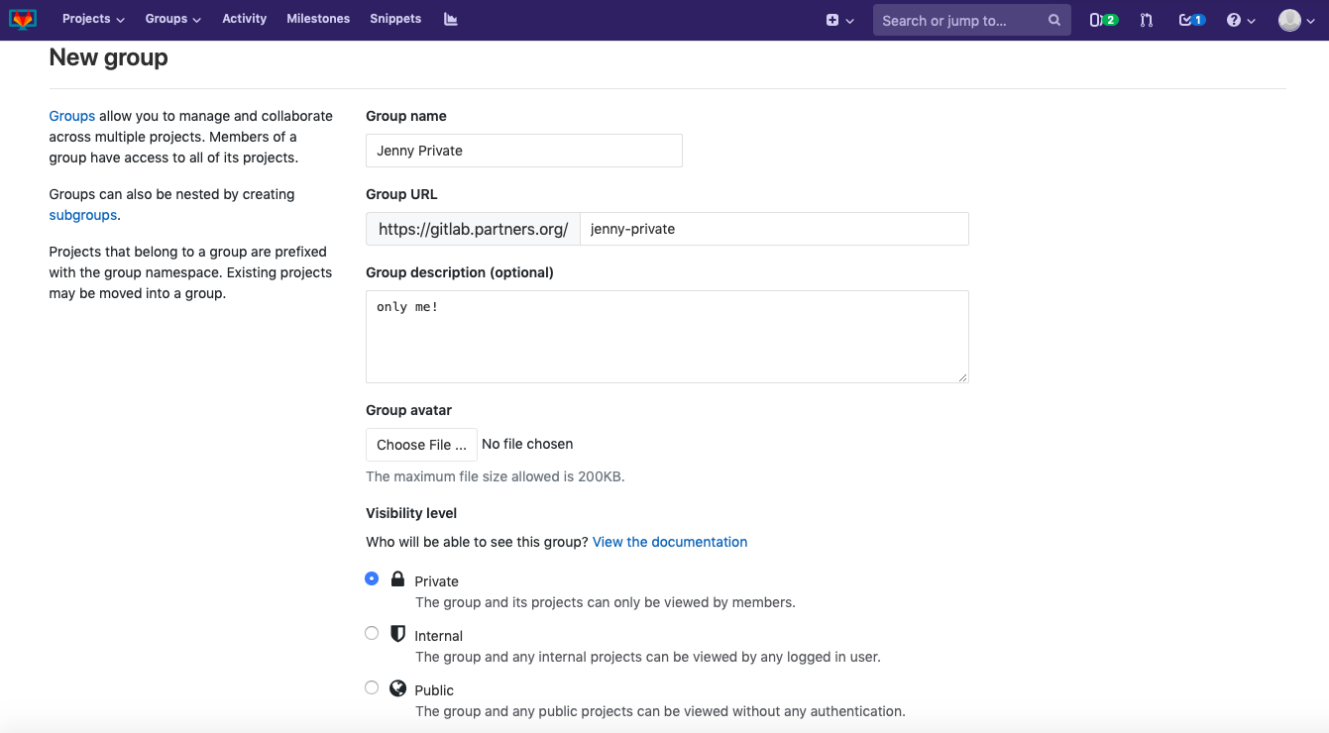
- Go to the group you just created. Click “New project”
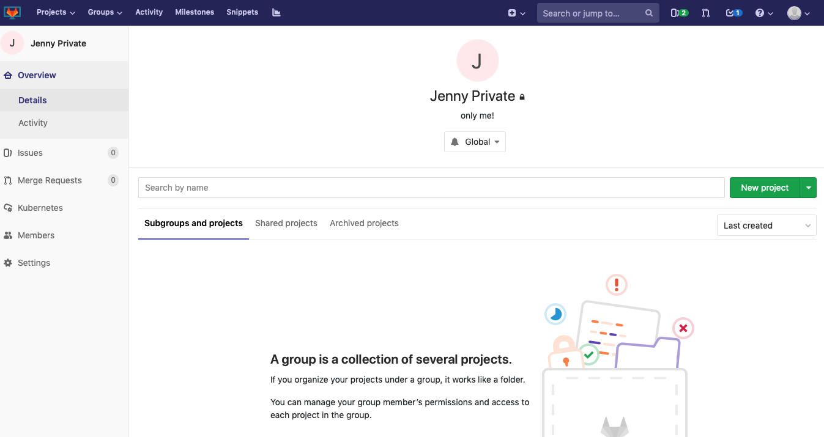
- Fill out the information about your project aka what your code is about, and create project.
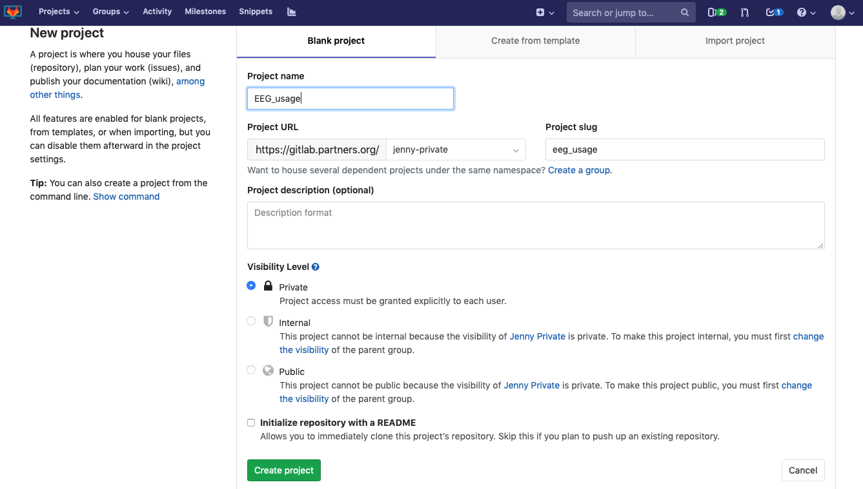
- You should see instructions on how to connect your laptop to gitlab cloud. If you have the code already on your laptop, follow “existing folder”. If you are writing new codes, follow “create a new repository”.
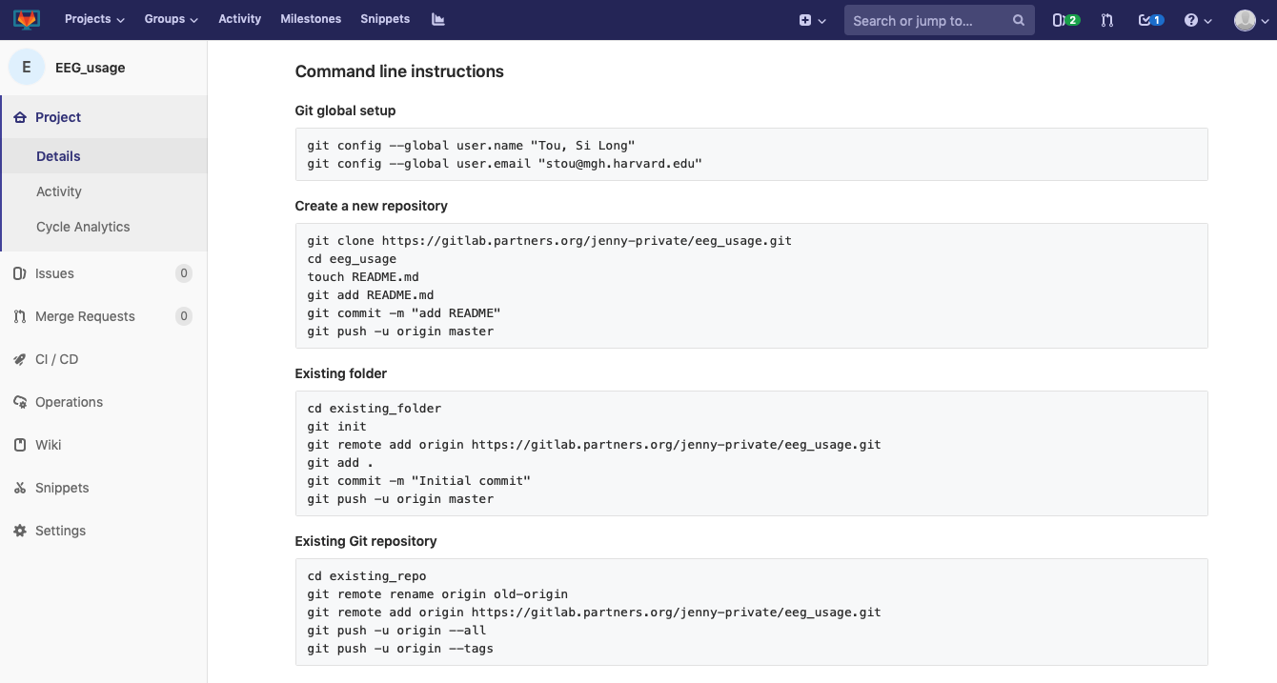
- Follow the instructions and type those lines in terminal/command prompt. You will be asked to put in your user name (partners id) and password. After you have done all that, navigate on gitlab to your project, you should see the new files with your commit comment.
